Invisible Ink Instructions
Materials
- Cornstarch
- Water
- Paper
- Iodine Solution

Instructions

- First, mix equal parts cornstarch and water together to make a paste.

- Use a cotton bud to write the message on a piece of paper. Allow it to dry.

- Using a paintbrush, rub the iodine over the words or drawing on the paper to reveal the hidden message. The iodine will turn the message purple.

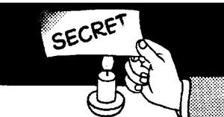

At home: Make heat-activated invisible ink
Pour some milk into a bowl (you won't need much). Dip a cotton bud into the milk. Carefully write your message trying not to get the paper too wet. Allow milk to dry.
When you are ready to read the message, place the paper in the oven (ask an adult for help with this) on a low heat.
The message will turn brown as the paper heats it up. Try to keep the paper from getting too close to the flame to avoid scorching and catching the paper on fire.

